1. Sum of Nums

Program Name: sumofnums.ypr
Given a number n, have Alonso calculate the sum of all the numbers between 0 and n

Example Input File
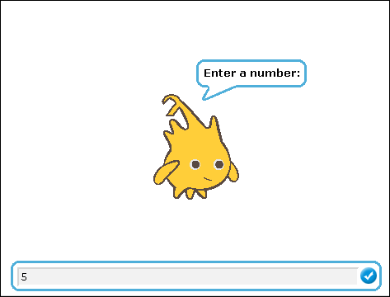

Example Output to Screen


